|  |
| --- |
|  |
| TFRS9 Model Development Document |
| Staff Loan |

Document History

This section documented the revision history and version control of this document. It shall record every major and minor revision of the model development document regarding the PD, EAD, LGD and SICR criteria models which are used for the purpose of calculation of ECL of the TFRS9 accounting book.

Revision History

|  |  |  |  |  |  |  |
| --- | --- | --- | --- | --- | --- | --- |
| **Version** | **Phase** | **Revision Date** | **Summary of Changes** | **Page** | **File name** | **Changed by** |
| 1.0 | 3.2 | 14-Jun-19 | Initial Version |  | KBank_TFRS9_Model_Development_Document_STAFF_V1.0_190614 | Lalita L. |

Reviewer

|  |  |  |  |
| --- | --- | --- | --- |
| **Name** | **Version** | **Signature** | **Review Date** |
| Nittha Praechanya | 1.0 |  |  |
| Thepdanai Danswasvong | 1.0 |  |  |
| Panrit Tosukhowong | 1.0 |  |  |
| Nareerut Poolpun | 1.0 |  |  |

Approvals

|  |  |  |  |
| --- | --- | --- | --- |
| **Name** | **Version** | **Signature** | **Approve Date** |
| Duangporn Kit-o-pas | 1.0 |  |  |
| Sanphet Sukhapesna | 1.0 |  |  |

# Introduction

Probability of default (PD), Exposure at default (EAD), and Loss Given Default (LGD) are three components which are used to calculate credit risk capital and provision. In this document, we are focusing on Staff loan portfolio which is a Term Loan. The portfolio size of Staff loan products is about 7,354,322,182 baht.

In the current regulatory setting, the provisioning of expected credit loss is calculated from inherent risk parameters; the probability of default (PD), exposure at default (EAD) and loss given default (LGD). Each parameter is estimated by average through the economic cycle from 2007 to 2009 which can be considered as a downturn situation. However, these risk parameters does not reflect future risk exposure. Hence, the TFRS9 which is a new accounting standard is introduced. The impairment under TFRS9 setting also covers forward-looking components which should help improve financial stability and improve bank credit risk.

This document outlines the development process of all model related to the TFRS9 calculation. For each risk component, this document shall clearly state the scope (model usage), methodology considered, model development approach, final model and the initial validation results.

# TFRS9 Expected Credit Loss

On July 24, 2014, the International Accounting Standards Board (IASB) issued the final version of the ‘International Financial Reporting Standard (IFRS) 9 – Financial Instruments’. As a primary component of the new accounting standard, the IASB introduced a forward looking impairment model. The IASB thereby reacted to delayed recognition of credit losses identified as a weakness of existing accounting standards during the course of the global financial crisis (of 2007/08). In particular, the biggest critique of incurred loss approach under IAS 39 was the recognition of credit losses only upon evidence of a trigger event. In this regard, IASB’s approach of forward looking credit loss estimation was evident from the below extract.

*“The new standard requires an entity to recognise expected credit losses at all times and to update the amount of expected credit losses recognised at each reporting date to reflect changes in the credit risk of financial instruments. This model is forward-looking and it eliminates the threshold for the recognition of expected credit losses, so that it is no longer necessary for a trigger event to have occurred before credit losses are recognised. Consequently, more timely information is required to be provided about expected credit losses.” [“Project summary – IFRS 9 Financial Instruments”, IFRS Foundation, 07/2014, p.14][1]*

Following the publication of IFRS 9 Financial Instruments in July 2014, the Basel Committee on Banking Supervision issued their ‘Guidance on Credit Risk and Accounting for Expected Credit Losses’ (GCRAECL) in December 2015. This covers in particular the impairment (Expected Credit Losses) element and how it should be embedded in and supported by internal processes.

Thai Accounting Standards are substantially converged with IFRS Standards, though the financial instruments Standards that are part of IFRS Standards have not yet been adopted. Thai Accounting Standards include several national financial instruments standards that differ from IFRS Standards. Henceforth TFRS9 can be considered as an adaptation from IFRS9 and replaces the existing TAS101.

***Principle 5 states****–A bank should have policies and procedures in place to appropriately validate models used to assess and measure expected credit losses. This presentation will provide an overview of the scope of work and the proposed validation approach for KBank, based on further discussions we will provide a more detailed view of the approach based on the complexity and materiality of the underlying models.*

Changes due to ‘*IFRS 9 – Financial Instruments*’ can be grouped into three categories.

* ***Classification and measurement***: Classification determines how financial assets and liabilities are accounted for in financial statements and, in particular, how they are measured on an ongoing basis:
  + Assets: one classification approach
  + Liabilities: addressing the volatility in profit or loss caused by changes in the credit risk of financial liabilities that are measured at fair value
* ***Impairments***: Forward-looking impairment model based on expected losses:
  + The new model requires entities to recognise expected credit losses at all times (12-month or lifetime expected loss) which includes measurement of changes in expected credit losses
  + It is no longer necessary for a trigger event to have occurred before credit losses are recognised
  + The new model is also accompanied by improved disclosures about expected credit losses and credit risk
* ***Hedge accounting***: Clear alignment with risk management:
  + The rules allow components of non-financial items to be hedged (previously not allowed by IAS 39)
  + IFRS 9 eliminates the distinction between financial and non-financial items and looks at whether a risk component can be identified and measured and therefore reflected in management activities

The primary change from IAS 39 to IFRS 9 is the evolution from an incurred loss view to a forward looking expected loss view which needs to be accounted for in the impairment models.

This new accounting standard will be effective from 2020. The IFRS 9 standard provides a new set of regulations that the new loss provisioning process will need to satisfy.



Figure 1, From IAS39 to IFRS 9

In particular, the new impairment rules require that the lifetime credit risk of an account be assessed at each model run to determine if there has been a significant increase in credit risk since origination. For accounts where the credit risk has significantly increased (including defaults) the lifetime expected credit losses must be used. If the credit risk has not significantly increased, then only credit losses resulting from expected defaults in the next 12 months must be used. The approach is outlined in terms of a stage classification accounting for significant increase in credit risk as a pivotal element of IFRS 9.

**Table 1: Stages under IFRS 9**

|  |  |  |  |
| --- | --- | --- | --- |
|  | **Stage 1** | **Stage 2** | **Stage 3** |
| **Stage description** | Includes accounts for whom no significant increase in credit risk since initial recognition has been observed | Includes accounts whose credit risk has significantly increased since initial recognition but no objective evidence of impairment has been observed, with a rebuttal presumption that this occurs when the account reaches 30 days past due | Includes accounts where the objective evidence of impairment has been observed |
| 12-month expected credit losses, i.e. credit losses due to default events within subsequent 12 months, are recognised in balance sheet | Lifetime expected credit losses (LTECL) i.e. credit losses due to default events spanning the (expected) lifetime of the facility, are recognised in balance sheet | Lifetime expected credit losses (LTECL) are recognised in balance sheet |
| **Expected loss** | IFRS 9 guidelines require to assess the 1 year expected credit losses without prescribing the tangible estimation procedure $$LTECL= \sum_{t=1}^{12}{{PD}_{t} × {EAD}_{t}} × {LGD}_{t}$$ $Where,$ ${PD}_{t}$ , ${EAD}_{t}$, ${LGD}_{t}$,, represent marginal PD, EAD and LGD at time *t* | IFRS 9 guidelines require the lifetime expected credit losses without prescribing the tangible estimation procedure $$LTECL= \sum_{t=1}^{T}{{PD}_{t} × {EAD}_{t}} × {LGD}_{t}$$ $Where,$ ${PD}_{t}$ , ${EAD}_{t}$, ${LGD}_{t}$,represent marginal PD, EAD and LGD at time *t* and *T* represents the remaining lifetime of the account | Expected loss of a defaulted client given the loss rate, i.e. the shortfall in net present value of expected cash flows versus the carrying amount of the loan |

Table , Stages under IFRS 9

The exemplary expected loss (EL) assessment in Table 1 listed above is based on an estimate of 1 year parameters probability of default (PD), loss given default (LGD) and exposure at default (EAD) for stage 1 and multi-year PD, LGD and EAD assessments for stage 2 including a discount factor to the reporting date.

# Definition

| **Term** | **Acronym** | **Description** |
| --- | --- | --- |
| Days Past Due | DPD | The number of days that an account is currently in arrears |
| Delinquent |  | An asset is described as delinquent if it is associated with any amount of arrears |
| Expected Loss/Expected Credit Loss | EL/ECL | Interchangeable terms. EL = PD*EAD*LGD |
| Exposure at Default | EAD | Exposure at Default (EAD) is defined as the expected amount drawn by borrowers at the time of default. |
| Probability of Default | PD | Probability of default (PD) is the risk that the borrower will be unable or unwilling to repay its debt in full or on time. The risk of default is derived by analyzing the obligor’s capacity to repay the debt in accordance with contractual terms. PD is generally associated with financial characteristics such as inadequate cash flow to service debt, declining revenues or operating margins, high leverage or declining liquidity |
| Default customer |  | Default customer is customer who failed to make on-time repayment (>= minimum payment rate) of their loans for more than ninety consecutive days or three months. |
| Conditional Prepayment Rate | CPR | Conditional Prepayment Rate (CPR) is the annualized percentage of the mortgage expected to prepay in each period. For example, if CPR is 5%, it means that 5% of mortgage is expected to prepay within the period. The focused population is the group of opening accounts at the end of time frame. |
| Lifetime Expected Credit Loss | LTECL / LEL | The Expected Credit Loss over the behavioural lifetime of an asset |
| Beta distribution |  | The beta distribution is a family of continuous [probability distributions](https://en.wikipedia.org/wiki/Probability_distribution) defined on the interval [0, 1] [parametrized](https://en.wikipedia.org/wiki/Statistical_parameter) by two positive [shape parameters](https://en.wikipedia.org/wiki/Shape_parameter), denoted by *α* and *β*, |

Table , Term definitions and descriptions

# Probability of Default

Probability of default (PD) is the risk that the borrower will be unable or unwilling to repay its debt in full or on time. The risk of default is derived by analyzing the obligor’s capacity to repay the debt in accordance with contractual terms. PD is generally associated with financial characteristics such as inadequate cash flow to service debt, declining revenues or operating margins, high leverage or declining liquidity.

With the new IFRS9 loan loss provision, loans are classified in three stages: stage 1 – initial recognition (yet to be impaired), stage 2 – significant increase in credit risk, and stage 3 – objective indicators of impairment. For loans in stage 1, banks need to estimate 1-year expected credit losses. On the other hand for loans in stage 2 and 3, banks need to provide provision and thus estimate expected credit losses for the whole lifetime of the loans. Both the 1-year and lifetime expected credit losses estimation shall reflect the banks’ forward looking macro-economic view.

KBank’s PD estimation for IFRS9 is modelled according to the following principles: (i) the PD estimation for IFRS9 should be point-in-time (PIT) and reflect current market conditions, (ii) the PD estimates should use structural and behavior information, and (iii) estimation of PD should include the forward looking aspect of the macroeconomic outlook specific to particular sector. For loans in stage 1 and 2, the modelled probability of default will be over 12 months and lifetime respectively. For stage 3, the probability default will be at 100%.

KBank leverages existing behavioral scorecard to construct a new credit rating system (supermaster rating) and then use it to create the probability of default term-structure of each obligor up to its maturity based on a continuous time homogeneous or non-homogeneous Markov transition matrix and then incorporate systematic risk into PD term-structure model via Vasicek model for calculating joint loss distribution of bank exposures (Vasicek, 2002).

This section outlines step by step Probability of Default (PD) model development methodology for the champion model and states its compliance with the current IFRS9 regulatory requirement. It also documented all the technical difficulties that the model developer experienced undergoing these model development steps.

## Scope

This probability of default model should be used to create the PD term structure for all valid stage-1 and stage-2 staff loan instruments. For stage-3 instruments, they are automatically assigned to be at 100%.

## Methodology Review

We utilize migration and generator matrix from housing loan portfolio. Please refer to the model development document of housing loan.

## Model Development

### Supermaster Scale and Rating

The first step in our PD term structure model development is the construction of supermaster rating and supermaster scale PD. For current loan and TDR customer, we use scoring model to create ratings and thus assign a suitable rating for each customer. For other asset classes, we directly observe the long run historical default rate within each asset class and assign them to an appropriate rating in the supermaster scale.

The outcome of this exercise is the supermaster rating and scale as shown below. The PD in each rating are calibrated to the long run default performance up to June 2016.

|  |  |  |  |
| --- | --- | --- | --- |
| **Supermaster Rating** | **Asset_flag** | **PD MasterScale** | **201612** |
| **30/1/2018** | **Actual DR** |
| 3 | PL Normal | 2.88% | Expert judgment |
| 6 | Reschedule | 8.90% |
| 7 | TDR | 20.07% |
| 5 | Watch List | 7.42% |
| 9 | SMA | 55.41% |
| SMQ |

Table 3, Super master Scale for PD

Note: Due to inadequate data of Staff loan portfolio, expert judgment is therefore required in order to assign supermaster rating and PD value.

### Probability of default term structure

We utilize migration and generator matrix from housing loan portfolio. Please refer to the model development document of housing loan.

## Pre-Validation

We utilize migration and generator matrix from housing loan portfolio. Please refer to the model development document of housing loan.

# Exposure at Default

EAD is one of the major components which are used to calculate credit risk capital and provision. Based on nature of the products, we can discriminate them into 2 product types which are Term Loan and Revolving Loan. For Retail Credit products, term loan is consisting of Housing Loan, Staff Loan, Other Secured Loan and K-Leasing. EAD-TFRS9 model will be segmented based on Term Loan and Revolving Loan as shown in Figure 2, Product Structure of Retail Product below. The first one is model for loan products and the other one is model for revolving products.

**Retail Product**

**B. Revolving Loan**

1. **Term Loan**

**Credit Card**

**POD**

**Housing Loan**

Other Secured Loan

**Consumer Loan**

**K-Express Cash**

Other Unsecured Loan

**Staff Loan**

New Car

Used Car

K- Car

**K-Leasing**

Figure , Product Structure of Retail Product

This development document will solely concentrate on the model for term loan as housing loan is considered as a term loan product. There is no EAD model specifically for staff loan portfolio but staff loan portfolio use EAD model developed for housing loan portfolio because both are home mortgage loan. As a result, EAD model development for staff loan portfolio is referred to housing loan model development document in EAD part.

***A: Term Loan***

The mortgage industry of Thailand pays a major role in consumer lending business. The market is fiercely competitive. Both government and commercial banks attempt to attract borrowers by offering special interest rate programs. Several programs are created such as fixed 1-year rate, fixed 2-year rate, fixed 3-year rate, and etc. Borrowers can match the rate with their preference. Moreover, banks in Thailand allow borrowers to pay off the loan before the contractual maturity (pre-payment) without any penalty. So, pre-payment and pre-settlement significantly reduces Bank’s revenue. If banks can foresee which borrowers are certainly to make full prepayment or ones are to refinance, banks can prepare the rates matching borrowers’ behavior in terms of interest rate scheme and costs. Another advantage of predicting prepayment is that banks can more effectively allocate their provision matching borrowers’ behavioral life time.

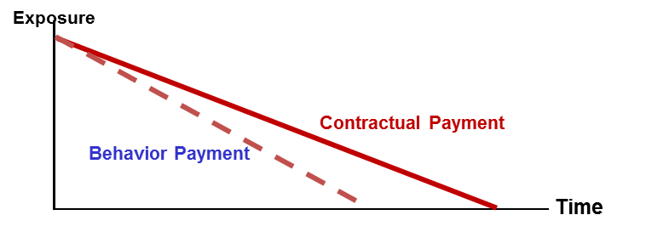The objective of this development is to more efficiently estimate customers’ lifetime and exposure curve. In other words, banks would like to know how long the borrowers stay in the

Figure : Concept of Prepayment Model

As shown in Figure 3, with the effect of prepayment, the remaining of exposure would be reduced when compared to contractual exposure. The effect can be incorporated by %CPR in equation below.

$${EAD}_{t}=OUT_{t-1}*{\left(1-{CPR}_{t}\right)}^{\frac{1}{12}} - CF_{t}$$

Where, ${EAD}_{t}$ is the Exposure At Default at time $t$

$OUT_{t}$ is outstanding amount at time $t$

$CPR_{t}$ is conditional prepayment rate at time $t$

$CF_{t}$ is the monthly contractual cash flow which generates from non-ECL part

Conditional Prepayment Rate (CPR) is defined as percentage rate of current prior-outstanding that will prepaid at any given time $t$ i.e.

$$CPR_{t}=\frac{\max\left(ACTUAL_PAYMENT_{t}-SCHEDULE_PAYMENT_{t},0\right)}{OUT_{t-1}}$$

Where, $ACTUAL_PAYMENT_{t}$ is the amount of actual payment made at time $t$

$SCHEDULE_PAYMENT_{t}$ is the amount scheduled to be paid at time $t$

$OUT_{t-1}$ is the beginning of the period outstanding at time $t$

(which essentially equals to end-of-period outstanding at time $t-1$)

**Conditional Prepayment Model**

The fundamental idea is to calculate Conditional Prepayment Rate (CPR) which is the annualized percentage of the mortgage expected to prepay in each period and expressed in the equation. For example, if CPR is 5%, it means that 5% of mortgage is expected to prepay within the period. The focused population is the group of opening accounts at the end of time frame.

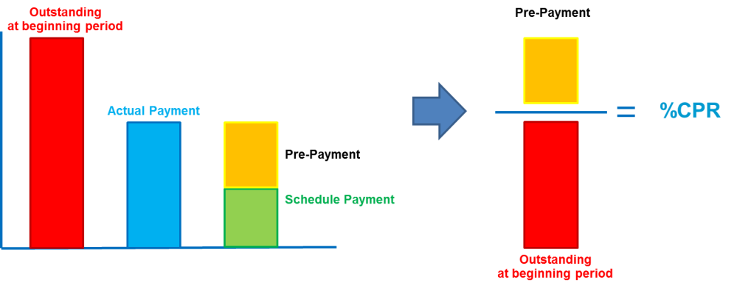

Figure : Conditional Prepayment Rate (CPR)

$$CPR=\frac{Prepayment within a period}{Beginning outstanding balance in a period}$$

However, Through-the-cycle and Point-in-Time CPR of staff loan product is as same as through-the-cycle CPR of Housing loan since Staff loan portfolio is small. Therefore, modeling methodology can be found in model development document of Housing loan.

# Loss Given Default

Loss given default, LGD, can be defined as the share of a defaulted exposure that will never be recovered by the lenders. The loss given default shall be assessed in an economic sense rather than a mere accounting perspective. That said the discount effect associated with the recovery cash flow and cost associated with collecting recoveries shall be considered.

For staff loan portfolio, there is no model specific for this portfolio. As staff loan is home mortgage loan which is same to housing loan, so staff loan use same constant estimated for housing loan that is 34.42%. This constant is used for downturn, through-the-cycle and point-in-time LGD. More detail about LGD model development will be found in housing loan model development document. For following part give information about how modeler could obtain LGD value from housing loan data using workout approach.

The LGD historical constant methodology is based on the discounted of actual cash flows that can be recovered by the collection process from the date of default to the end of the recovery process. In addition, BIS (2004) states that banks who choose to calculate realized LGD using the workout method must include the direct and indirect costs associated with the collection of the exposure. Thus, we consider both costs in our LGD calculation. Direct costs are those associated with a particular asset, including fees for an appraisal of collateral, costs of selling assets, costs of running a business, and other professional fees. Indirect costs are necessary to carry out the recovery process but are not associated with individual facilities. For KBank portfolio, collateral is generally held against a customer, not against an individual loan. Thus, for the calculation of historical LGD, it makes sense to view all of a given customer’s facilities as a single exposure, and calculate the severity based on this.

**Non-Closed Files Customer Treatment**

When using the workout method, the problem arises of how to deal with partial recovery profiles of non-closed files. The non-closed files refer to defaulted customers in the database who do not yet complete the loan recovery process (i.e. many of the loans are still in the process of debt collection).

The simplest approach is to exclude these non-closed files from the LGD estimation process, with LGD based on closed files only. Whilst simple, results based on this approach may be affected by data selection bias if the non-closed files contain information relevant to LGD which is not captured by the recovery profiles of the closed files. Moreover, inclusion of the non-closed files may still be relevant if they contribute to reduce the error around the estimates (Rapisarda and Echeverry, 2010).

As a result, we include the non-closed files in the LGD estimation process and need to make an assumption on the recovery rate of the non-closed files. In doing so, we first divide the closed files into four main default pathways, as shown in Figure 5: Recovery rate of closed accounts by path, and estimate each group recovery rates:

|  |  |
| --- | --- |
| Path | Explanation |
| Self Cured | The defaulted customer takes a certain amount of time to recover. However, No significant loss and no change in the structure or conditions of the facilities. |
| Early Cured | The defaulted customer takes a certain amount of time to recover and might not be able to fulfill his/her contractual obligations from time to time. However, No significant loss and no change in the structure or conditions of the facilities. |
| Restructuring | The defaulted customer recovers after a restructuring of his/her facilities. Usage of collateral may sometimes be part of the restructuring. Loss amount varies whereas customer relationship maintained |
| Liquidation | All facilities of the defaulted customers are liquidated, i.e. sales of loans, usage of collateral, etc. Loss amount is generally higher than that observed from restructuring. End of customer relationship. |

Table , All possible paths and their definition

However, Analysis of characteristics and historical LGD between self-cured and early cured is very similar. Figure 5 shows that the recovery curve of closed accounts in path of self-cured and early cured is slightly different in early period but is very close in later period.

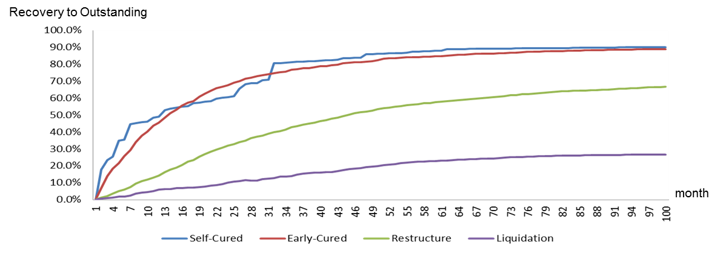

Figure : Recovery rate of closed accounts by path

The evidence supports that these two groups, self-cured and early cured, is very similar. The modeler decides to group them together as shown in Table 5.

|  |  |
| --- | --- |
| Path | Explanation |
| Early Cured | The defaulted customer takes a certain amount of time to recover and might not be able to fulfill his/her contractual obligations from time to time. However, No significant loss and no change in the structure or conditions of the facilities. |
| Restructuring | The defaulted customer recovers after a restructuring of his/her facilities. Usage of collateral may sometimes be part of the restructuring. Loss amount varies whereas customer relationship maintained |
| Liquidation | All facilities of the defaulted customers are liquidated, i.e. sales of loans, usage of collateral, etc. Loss amount is generally higher than that observed from restructuring. End of customer relationship. |

Table : Final version of Paths and definition

We then classify the non-closed customers into each group of state and project each group’s recovery rates following those of the closed files. We project the remaining cash flows of non-closed customers based on the average recovery rate of closed group of customers by month. Here is the equation for this approach:

$$\% {CF}_{ij}=\frac{ \sum_{i=1}^{n}{Discount Cash Flow (i)}}{{EAD}_{i}}$$

$$\% Remaining=1- \% {CF}_{ij}$$

$$\%Recovery=\%{CF}_{ij}\left(month 0 to n\right)+\%Expected Recovery(month n to end)$$

Expected Recovery (%) is derived from projected recovery rate curve of each state and segment group. We can generate this curve by dividing all cash flow by outstanding of all closed-customers in that particular group and repeat this step for the next month till the end.

For example, if the customer has % Actual Recovery equal to 20% at month 36 after NPL date. Then we get an expected recovery from the curve which appears to be 30% from month 36 to the end of recovery curve. As a result, % Recovery of this customer must be 50% (20%+30%). For LGD, the following formula will be used:

$$\% LGD=max⁡(\% Recovery, 100\%)$$

# Criteria for a Significant Increase in Credit Risk (SICR)

With the new IFRS9 loan loss provision, loans are classified in three stages: stage 1 – initial recognition (yet to be impaired), stage 2 – significant increase in credit risk, and stage 3 – objective indicators of impairment. For loans in stage 1, banks need to estimate 1-year expected credit losses. On the other hand for loans in stage 2 and 3, banks need to provide provision and thus estimate expected credit losses for the whole lifetime of the loans. Both the 1-year and lifetime expected credit losses estimation shall reflect the banks’ forward looking macro-economic view.

The criteria for significant increase in credit risk (stage transfer criteria) will be used for the classification of loans between stage 1 and stage 2. KBank employed both the qualitative and the quantitative criteria for stage classification. An example of qualitative stage transfer criteria stage is the 30+ days past due (DPD), fraud, black list from the revenue department and so on. Thus, all instruments with DPD>30 days are automatically classified as stage 2. This model development document solely focus on the formulation of the quantitative stage transfer criteria.

This section of the document outlines the methodology review and the development including any expert opinions and judgements of our champion significant increase in credit risk criteria. KBank explore four methodologies to develop the quantitative criteria the significant increase in credit risk namely the rating downgrade criteria, the remaining lifetime PD criteria, the forward run test and the high credit risk region. In each of the methodology, KBank leverages existing behavioral scorecard, supermaster rating transition matrix and PD term structure to induce statistical inference and the formulation of the criteria itself.

Please refer to the model development document of housing loan.

1. http://www.IFRS.org/current-projects/iasb-projects/financial-instruments-a-replacement-of-ias-39-financial-instruments-recognitio/documents/IFRS-9-project-summary-july-2014.pdf